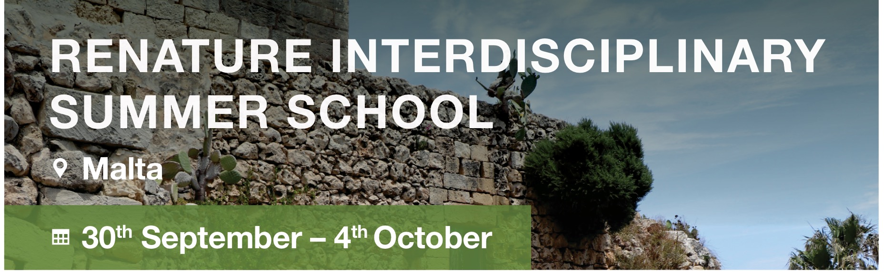

APPLICATION FORM
DEADLINE FOR APPLICATIONS: 10TH JULY 2019
After you fill in the form, please send it to Judita.Tomaskinova@mcast.edu.mt and Renata.Mikalauskiene@mcast.edu.mt. We will confirm receipt by email.
PERSONAL DETAILS:
- First name: __________________________
- Family name: __________________________
- Preferred name: __________________________
- Date of birth: __________________________
- Nationality: __________________________
- Country of residence: __________________________
- Postal address (Personal): (Street, Town/City, Province/Region, Country, ZIP/Post code): __________________________
- Email: __________________________
- Mobile Phone (incl. area code): __________________________
- Do you require a visa? Yes/No
- Please list here any special support needs or medical conditions that may affect your participation (e.g. physical disability, special diet, allergies, etc.).
__________________________________________________________________________________________________________________________________________
We welcome applications from all students, including students with additional support needs. If you think you may need extra support during the summer school, please let us know so our ReNature Team can help.
First Language: __________________________

Your proficiency in English:
- Beginner
- Intermediate
- Advanced
- Fluent

Your current occupation: __________________________
ACADEMIC DETAILS:
- Home University / Institution / Faculty / Department: __________________________
- Name of your degree programme: __________________________
- List all your academic degrees and titles of your MA/PhD projects: __________________________
EMERGENCY CONTACT:
- Emergency contact name and relationship to you (e.g. parent, etc.): __________________________
- Emergency Contact Telephone: __________________________
- Emergency Contact Email: __________________________
Through the support provided by the COST Action Circular City, the organising team are able to offer a limited number of travel grants to PhD students who are interested in joining the ReNature 1st Summer School – Nature-based solutions in landscape management.
WOULD YOU LIKE TO APPLY FOR A TRAVEL GRANT? Yes/No
Since places and grants for participation are limited, applications will be reviewed by members of the organising team in collaboration with the COST Action Circular City. You are kindly requested to provide us with the following information:
- Your short CV (max. 2 pages);
- Motivation letter: Please explain your motivation for applying to attend the Summer School and what you hope to achieve by joining (max. 300 words);
- An abstract for your poster presentation (max. 250 words).
- A signed copy of the Informed Consent Form. (available at www.renature-project.eu/show/1783_apply)

ADDITIONAL INFORMATION:
- I certify that all information I have provided in this form is true and correct and I understand that the ReNature Team has the right to cancel any registration or the travel grant if any of these statements prove to be incorrect. I accept full responsibility for all information provided on this form.
- By submitting this application form, I give ReNature and the COST Action Circular City permission to use my personal details for the application process.
- I have read the ReNature Participant Information Sheet and am submitting a signed copy of the Informed Consent Form with this application.
If you have queries regarding the ReNature's use of your personal data, please contact the MCAST's Data Protection Officer at dpo@mcast.edu.mt.

The ReNature Team will be in contact with a decision regarding your application by the 31st July 2019.

http://renature-project.eu/
http://circular-city.eu/

